
CS 255 System Design Document Template

This template lays out all the different sections that you need to complete for Project Two. Each section has guidance to prompt your thinking. You will need to continually reference the interview transcript as you work to make sure that you are addressing your client’s needs. There is no required length for the final document. Instead the goal is to complete each section based on what your client’s needs are. Remove this note when you are finished, and replace all bracketed text with the relevant information.

UML Diagrams

UML Use Case Diagram
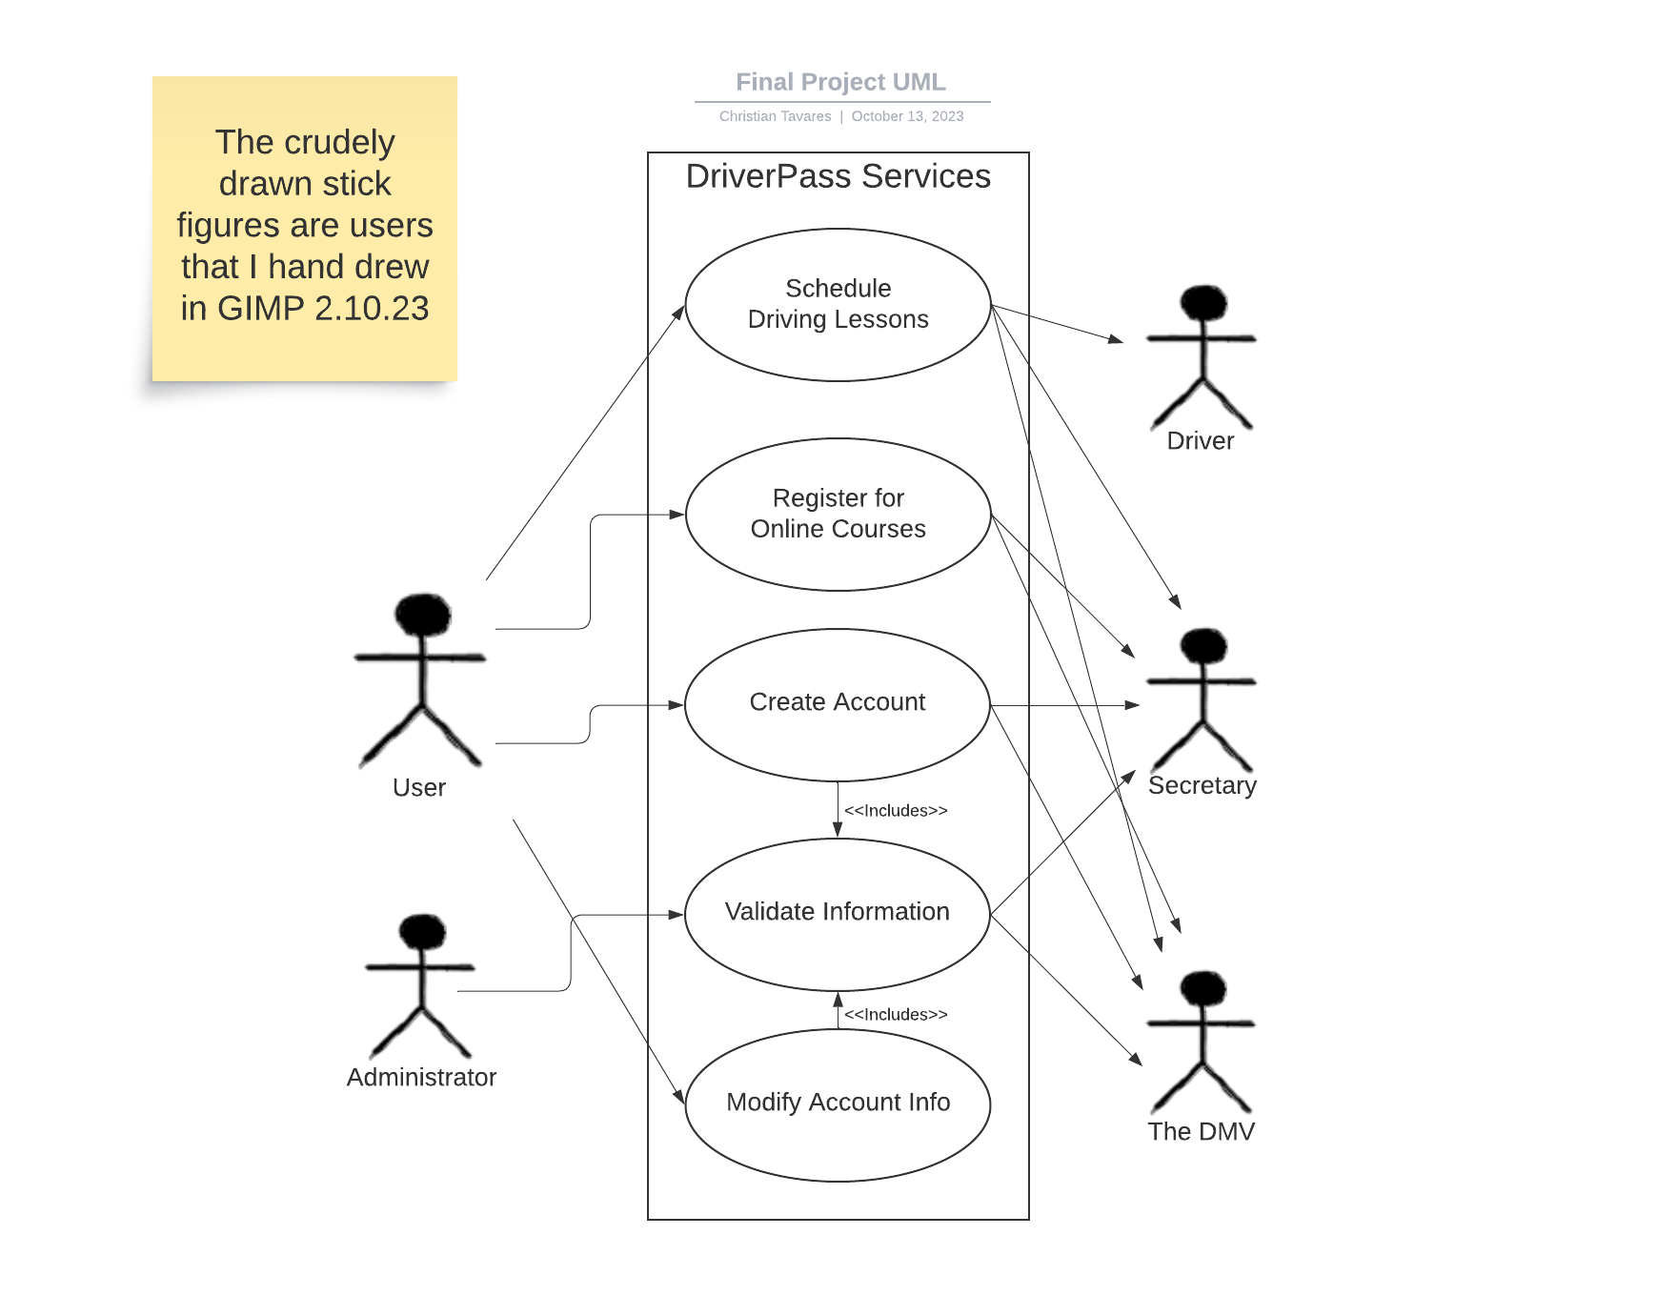

UML Activity Diagrams
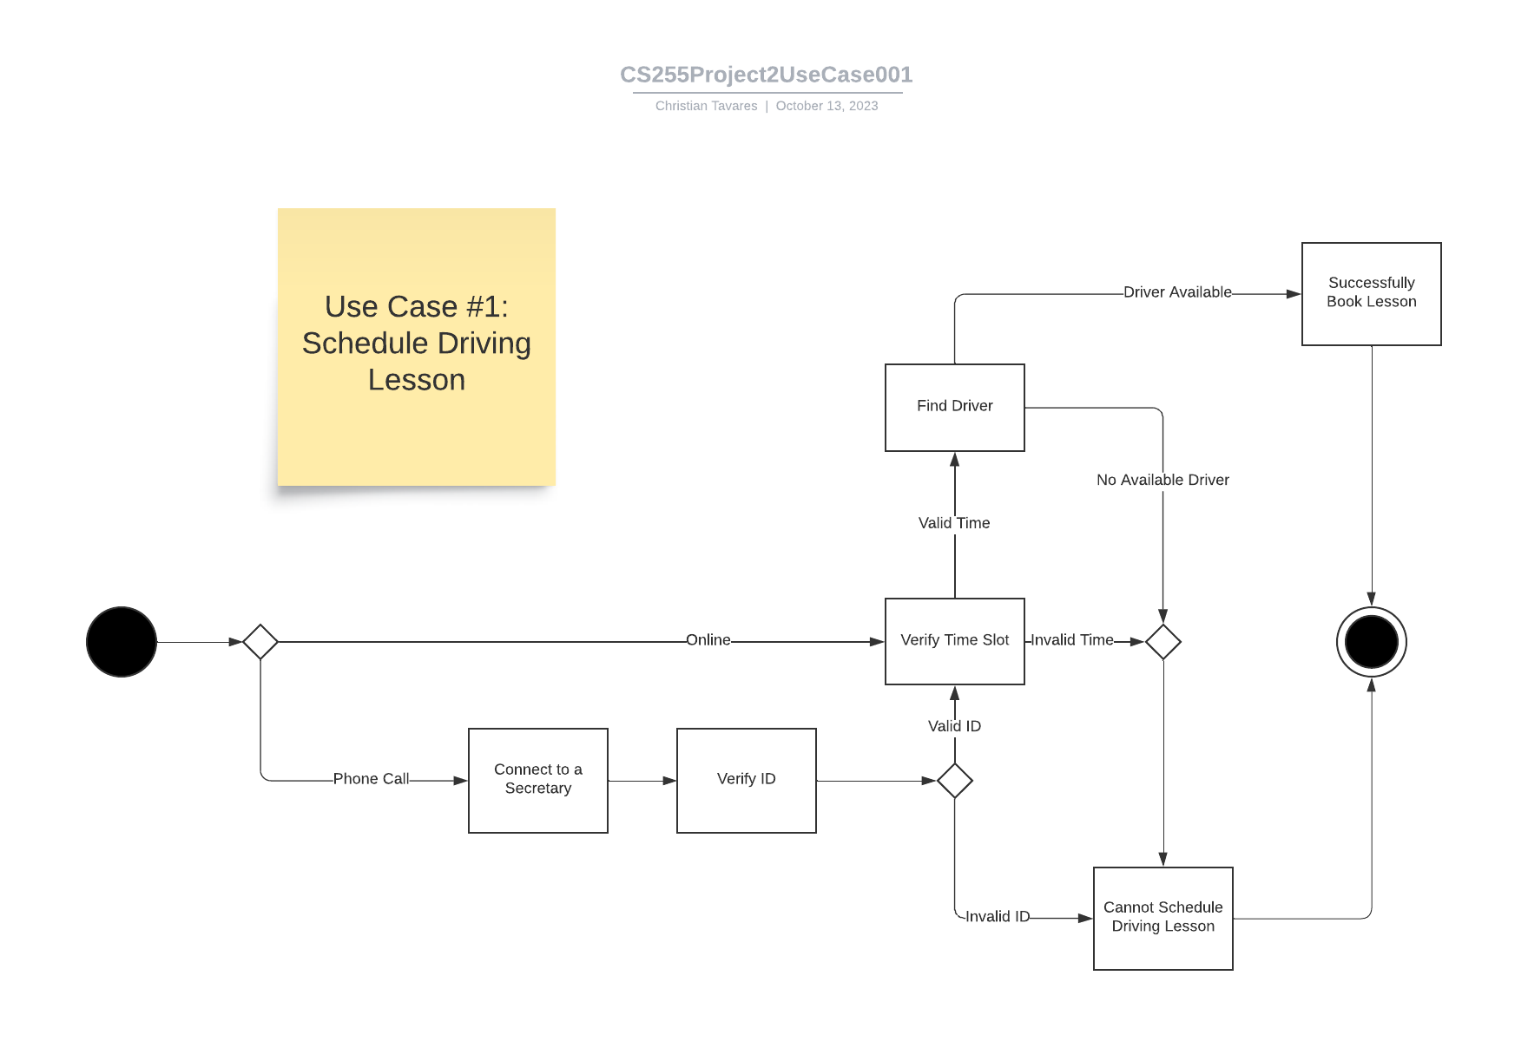
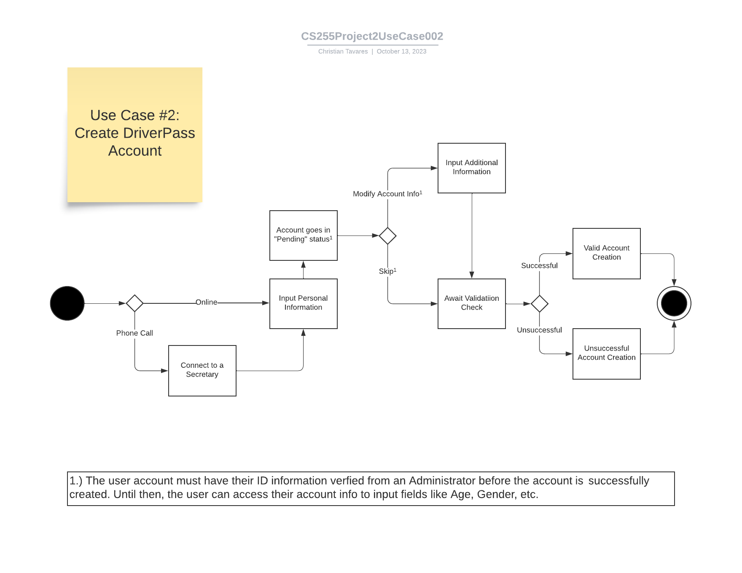

UML Sequence Diagram
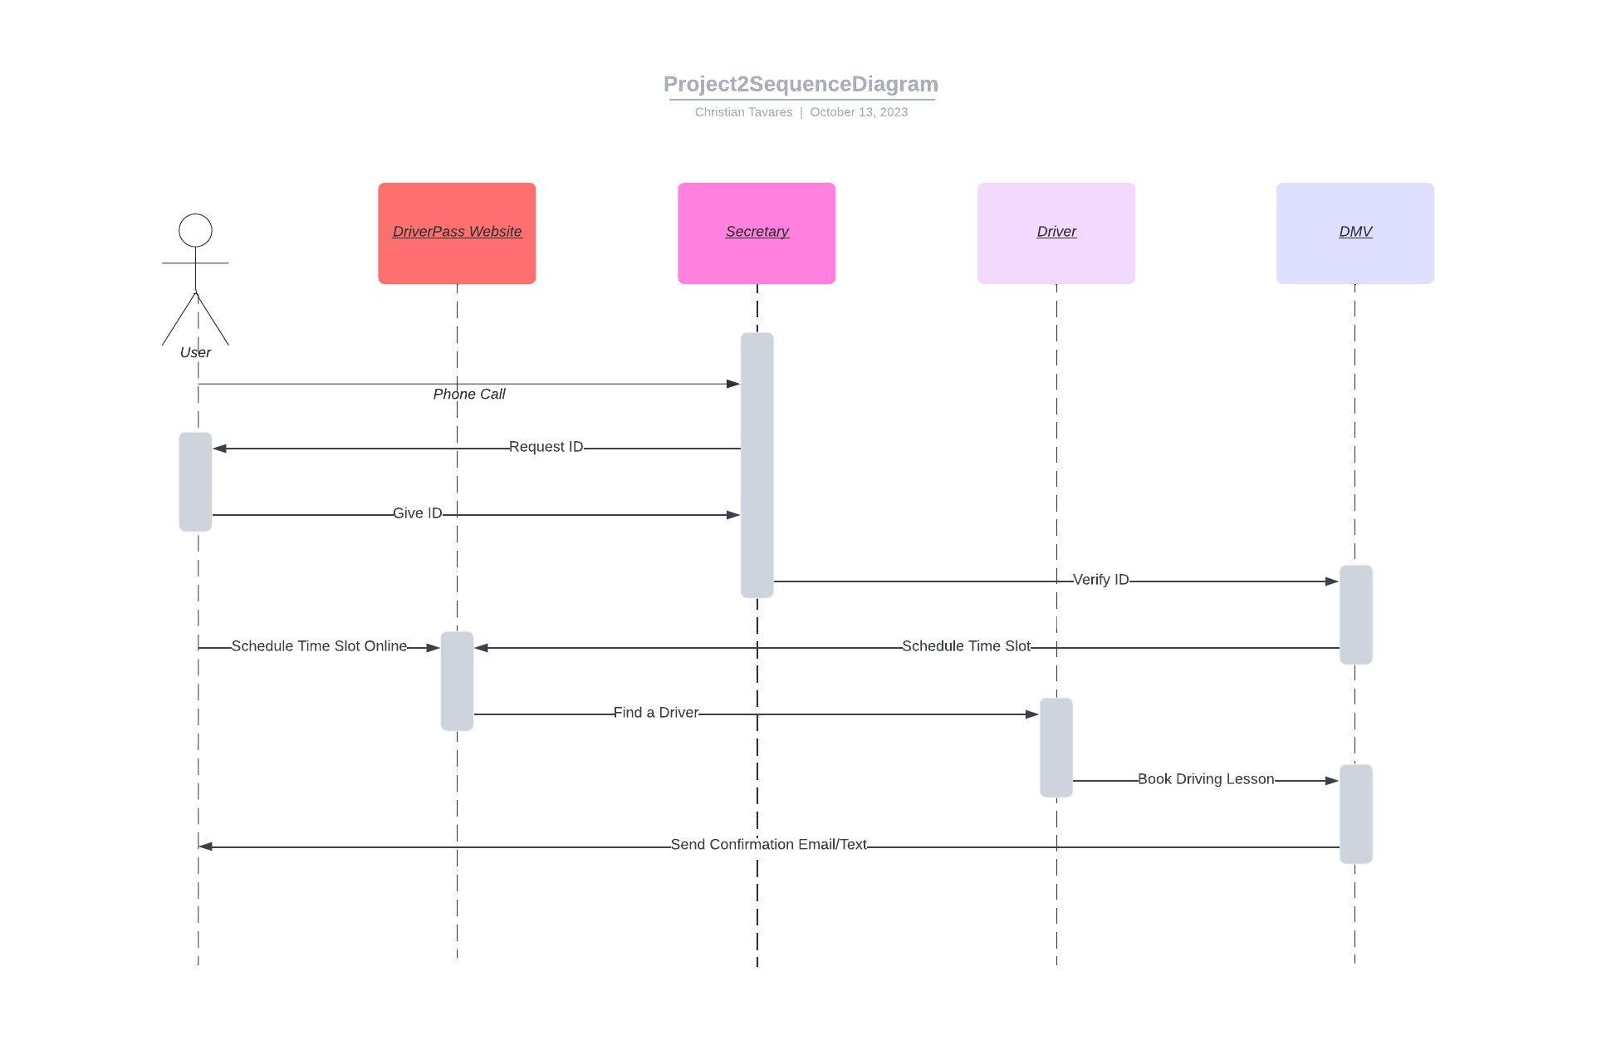

UML Class Diagram
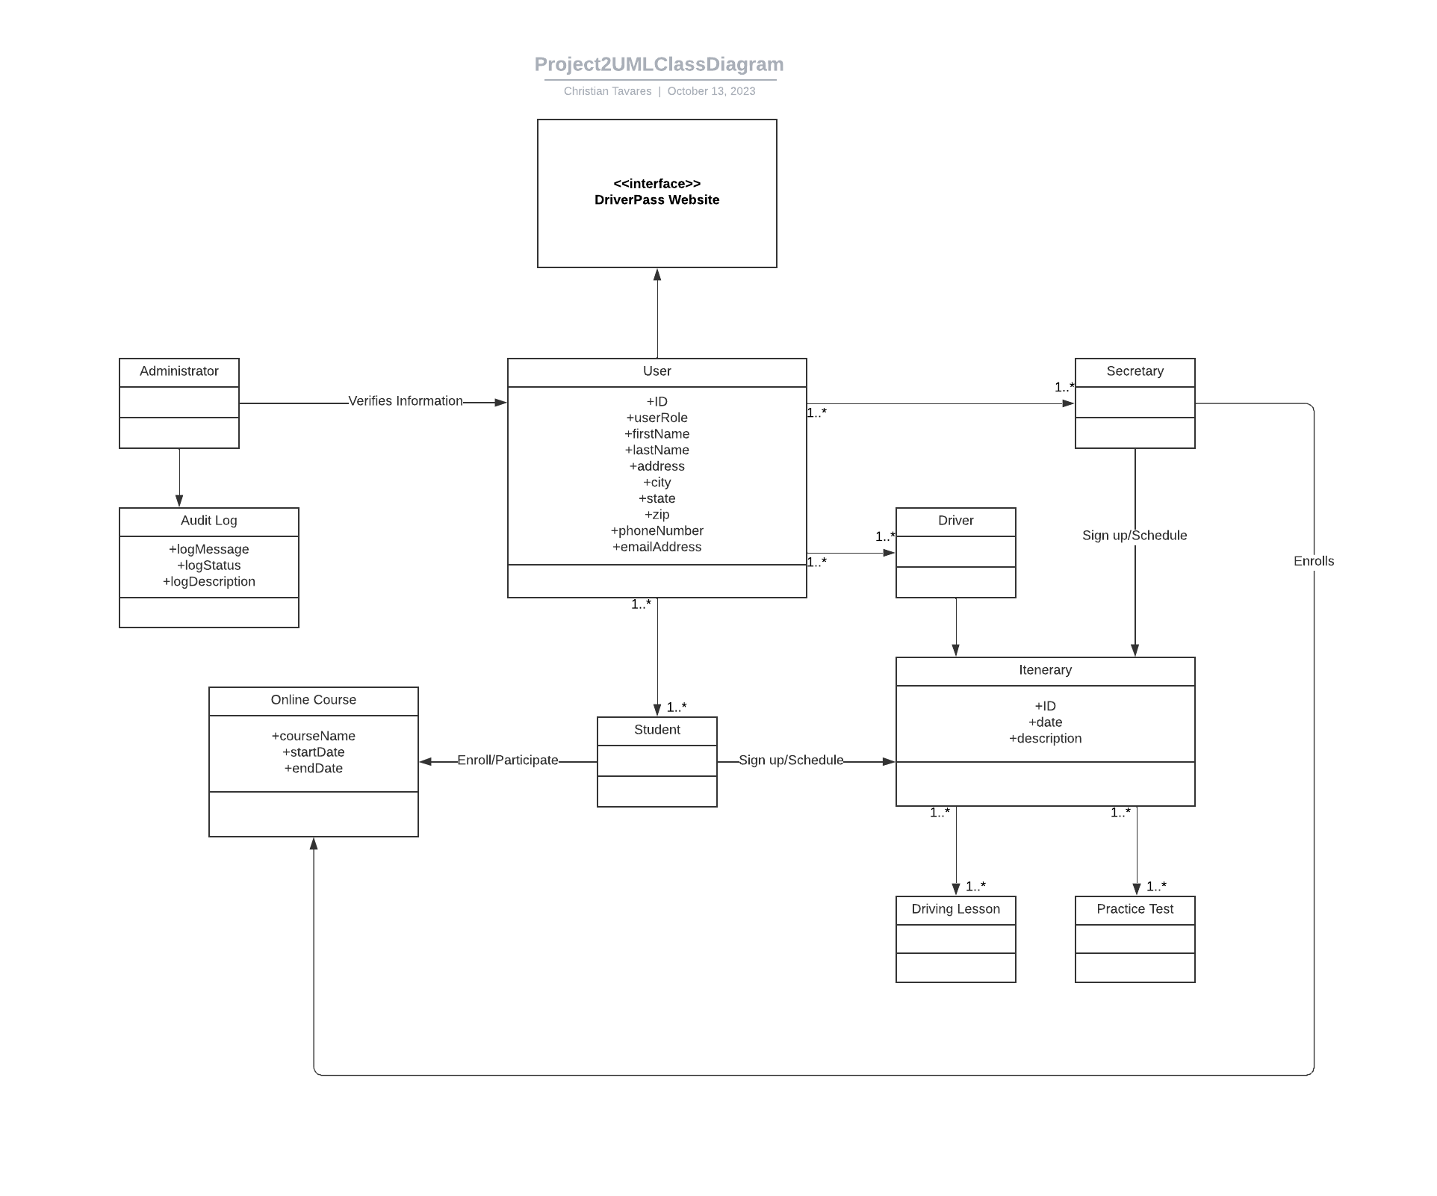

Technical Requirements

- Hardware
  - A personal machine for each Secretary and Administrator on site.
  - Server machines to host the website and database.
  - Basic peripherals for said machines (mouse keyboard, speakers, etc).
  - Laptop machines for Administrators to use if needed to work remotely.
  - Wiring, internet connections to establish a LAN to connect to server.
  - On site surveillance cameras.
  - Digital pin pad locks.
- Software
  - Windows OS for all machines, preferably most up to date.
  - Security software for cameras and potentially pin pads.
  - Framework software for server machines and database to run.
- Geographic Information
  - All equipment would be placed on site in the designated DriverPass building.
  - The entrance would be under surveillance with Secretary machines.
  - The entrance room will connect to the server room.
  - Server room is passcoded with digital locks and under surveillance.

